# RIBS IDENTIFICATION, LABELING

# AND

**DISEASE DETERMINATION**

***by***

|  |  |
| --- | --- |
| ***M Rupesh kumar Yadav*** |  |
| ***420207*** |  |
|  |  |

***Under the guidance of***

### Dr. C Sri Latha



**DEPARTMENT OF COMPUTER SCIENCE AND ENGINEERING NATIONAL INSTITUTE OF TECHNOLOGY ANDHRA PRADESH TADEPALLIGUDEM-534101, INDIA**

**APRIL-2022**

# RIBS IDENTIFICATION, LABELING AND

# DISEASE DETERMINATION

***Submitted in the partial fulfillment of the requirements of the degree of***

***Bachelor of Technology***

|  |  |
| --- | --- |
| ***by*** |  |
| ***M Rupesh Kumar Yadav*** | ***420207*** |
|  |  |
|  |  |

### Supervisor:

**Dr. C. Sri Latha**



**DEPARTMENT OF COMPUTER SCIENCE AND ENGINEERING NATIONAL INSTITUTE OF TECHNOLOGY ANDHRA PRADESH TADEPALLIGUDEM-534101, INDIA**

**APRIL-2022**

© 2022. All rights reserved to NIT Andhra Pradesh

# PROJECT WORK APPROVAL

This project work entitled **“**RIBS IDENTIFICATION, LABELING AND DISEASE DETERMINATION**”** was worked out by Mediboyina Rupesh Kumar Yadav (420207) is approved for the degree of Bachelor of Technology in Computer Science and Engineering

### Examiners

**Supervisor(s)**

**Chairman**

Date: 29-04-2022

Place: Tadepalligudem

# DECLARATION

We declare that this written submission represents our ideas in our own words and where others' ideas or words have been included, we have adequately cited and referenced the original sources. We also declare that we have adhered to all principles of academic honesty and integrity and have not misrepresented or fabricated or falsified any idea/data/fact/source in our submission. We understand that any violation of the above will be cause for disciplinary action by the Institute and can also evoke penal action from the sources which have thus not been properly cited or from whom proper permission has not been taken when needed.

|  |  |
| --- | --- |
| Mediboyina Rupesh Kumar Yadav |  |
| 420207 |  |
| Date : 29-04-2022 |  |

# CERTIFICATE

It is certified that the work contained in the thesis titled “**RIBS IDENTIFICATION,LABELING AND DISEASE DETERMINATION**” by “Mediboyina Rupesh Kumar Yadav, bearing Roll No: 420207” has been carried out under my supervision and that this work has not been submitted elsewhere for a degree.

### Dr. C. SRI LATHA Computer Science and Engineering

**N.I.T. Andhra Pradesh**

**April 2022**

|  |  |  |
| --- | --- | --- |
|  | **LIST OF FIGURES** |  |
| **Figure** | **Title** | **Page No.** |
| 1 | The Building of VinDr-CXR Dataset | 06 |
| 2 | Data Filtering | 07 |
| 3 | The U-net Architecture | 09 |
| 4 | Processing | 10 |
| 5 | Workflow | 14 |
| 6 | The Process of identification and labeling of ribs | 17 |
| 7 | Segmentation result-test | 18 |
| 8 | Segmentation results on our validation set and two external datasets. | 19 |
|  | **LIST OF TABLES** |  |
| **Table** | **Title** | **Page No.** |
| 1 | List of various Datasets | 15 |
| 2 | Segmentation performance on the validation set of VinDr-RibCXR | 18 |
|  |  |  |

# LIST OF SYMBOLS AND ABBREVIATIONS

**Notation Meaning**

CXR Chest X-ray

DL Deep Learning

DICOM Digital Imaging and Communications in

Medicine

CNN Convolutional Neural Network

FPN Feature Pyramid Network

PA Posterior – Anterior

AP Anterior – Posterior

lr Learning Rate

vi

# ABSTRACT

Over the years The Medical procedures had evolved and became so advanced that they can predict the diseases in advance but when we go a little back to make it all possible, It required the study and diagnosis of the symptoms and conditions of the particular diseases and conditions and when it came to study of Lungs, cardio, diagnosing tumors, bone injuries and other respiratory diseases it became evident to study by using X-rays. Chest radiography (chest X-ray or CXR) is an economical and easy-to-use medical imagine and diagnostic technique. The technique is the most commonly used diagnostic tool in medical practice and has an important role in the diagnosis of the lung disease. The traditional way of identifying ribs by handpicking is not feasible in the case of identification of anterior bones, thus requiring the technical and analytical solutions, where Deep Learning (DL) has shown superior performance to other methods in the segmentation and labeling of individual ribs. Developing DL algorithms for this task requires annotated images for each rib structure at pixel-level. The Dataset VinDr-RibCXR is used for automatic segmentation and labeling of individual ribs from chest X-ray (CXR) scans. The VinDr-RibCXR contains 245 CXRs with corresponding ground truth annotations provided by human experts. A set of state-of-the-art segmentation models are trained on 196 images from the dataset to segment and label 20 individual ribs. The State-of-the-Art segmentation models like U-Net, U-Net with EffecientNet-B0 ,Feature Pyramid Network (FPN) with EffecientNet-B0, and U-Net++ with EffecientNet-B0 are used for the task .Our best performing model obtains a Dice score of 0.834 (95% CI, 0.810{0.853) on an independent test set of 49 images.The same experiment is conducted with other datasets like JSRT and Shenzen and the results are recorded for further analysis.

# TABLE OF CONTENTS

### Page No

Title i

Project Work Approval ii

Declaration iii

Certificate iv

List of Figures v

List of Tables v

List of Symbols and Abbreviations vi

Abstract vii

Table of Contents viii

Acknowledgement 22

Contents

Page No.

1. CHAPTER 1
   1. Introduction 1
2. CHAPTER 2
   1. Ribs Segmentation using Deep Learning 3
3. CHAPTER 3
   1. Problem Statement 4
4. CHAPTER 4
   1. Ribs Identification 5
   2. Dataset Acquisition 5

4.2.1 Data Collection 6

4.2.2 Data Filtering 6

4.2.3 Data Lableing 7

* 1. VinDr-CXR Dataset 8
  2. Masking & Segmentation 8

4.4.1 U-Net 9

4.4.2 U-Net Architecture 9

4.4.3 Building U-net model for Segmentation 10

4.5. Analysing various CNN 12

4.5.1 Building The Model 13

4.5.2 Creating optimizer with per-layer learning rate and weight decay 14

1. CHAPTER 5

5.1. Experimental Procedure 15

1. CHAPTER 6
   1. Results and Discussion 17

## Experiment using A Single Dataset and multiple CNN’s 17

* 1. Experiments using various Datasets 19

1. CHAPTER 7

7.1. Conclusion and Future Scope 20

1. CHAPTER 8

8.1. Reference 21

# Chapter 1

**Introduction**

Over the years Medical procedures had evolved and became so advanced that they can predict the diseases in advance but when we go a little back to make it all possible, It required the study and diagnosis of the symptoms and conditions of the particular diseases and conditions and when it came to study of Lungs, cardio, diagnosing tumors, bone injuries and other respiratory diseases it became evident to study by using X-rays , And to study the Calcium deposits. An x-ray is a quick, painless test that produces images of the structures inside your body – particularly bones. X-ray beams pass through body and they are absorbed in different amounts depending on the density of the material they pass through.

Chest x-ray uses a very small dose of ionizing radiation to produce pictures of the inside of the chest. It is used to evaluate the lungs, heart and chest wall and may be used to help diagnose shortness of breath, persistent cough, fever, chest pain or injury. It also may be used to help diagnose and monitor treatment for a variety of lung conditions such as pneumonia, emphysema and cancer. Because chest x-ray is fast and easy, it is particularly useful in emergency diagnosis and treatment

Chest radiography (chest X-ray or CXR) is an economical and easy-to-use medical imagine

and diagnostic technique. The technique is the most commonly used diagnostic tool in

medical practice and has an important role in the diagnosis of the lung disease.

Chest radiography contains a large amount of information about a patient’s health.

* **The Condition of the Lungs :** Chest X-rays can detect cancer, infection or air collecting in the space around a lung, which can cause the lung to collapse. They can also show chronic lung conditions, such as emphysema or cystic fibrosis, as well as complications related to these conditions.
* **Heart-related Lung Problems.** Chest X-rays can show changes or problems in your lungs that stem from heart problems. For instance, fluid in your lungs can be a result of congestive heart failure
* **Blood vessels.** Because the outlines of the large vessels near your heart the aorta and pulmonary arteries and veins are visible on X-rays, they may reveal aortic aneurysms, other blood vessel problems or congenital heart disease
* **The size and outline of the heart.** Changes in the size and shape of your heart may indicate heart failure, fluid around the heart or heart valve problems.
* Chest X-rays can reveal fluid in or around your lungs or air surrounding a lung.
* **Calcium deposits.** Chest X-rays can detect the presence of calcium in your heart or blood vessels. Its presence may indicate fats and other substances in your vessels, damage to your heart valves, coronary arteries, heart muscle or the protective sac that surrounds the heart. Calcified nodules in your lungs are most often from an old, resolved infection.
* **Fractures.** Rib or spine fractures or other problems with bone may be seen on a chest X-ray.
* **Postoperative changes.** Chest X-rays are useful for monitoring the recovery of the patient after the surgery in the chest, such as on your heart, lungs or esophagus.

X-rays are a form of radiation like light or radio waves. X-rays pass through most objects, including the body. The technologist carefully aims the x-ray beam at the area of interest. The machine produces a small burst of radiation that passes through your body. The radiation records an image on photographic film or a special detector. Different parts of the body absorb the x-rays in varying degrees. Dense bone absorbs much of the radiation while soft tissue (muscle, fat, and organs) allow more of the x-rays to pass through them. As a result, bones appear white on the x-ray, soft tissue shows up in shades of gray, and air appears black.

On a chest x-ray, the ribs and spine will absorb much of the radiation and appear white or light gray on the image. Lung tissue absorbs little radiation and will appear dark on the image.

# Chapter 2

## 2.1. Ribs Segmentation using Deep Learning

Using Deep Learning to study the structures and Positioning of Anterior and Posterior Ribs. Deep Learning (DL) has shown superior performance to other methods in the segmentation and labeling of individual ribs. Developing DL algorithms for this task requires annotated images for each rib structure at pixel-level. To the best of our knowledge, there exists no such benchmark datasets and protocols. VinDr-RibCXR a benchmark dataset for the automatic segmentation and labeling of individual ribs on CXRs has been used for reference.

Various state-of-the-art DL-based segmentation models are used for the task of individual rib segmentation and labeling, including U-Net, U-Net with EffecientNet-B0 Feature Pyramid Network (FPN) with EffecientNet-B0, and U-Net++ with EffecientNet-B0. These models are well-known to be effective for many medical image segmentation tasks. To train the networks, all the images are resized to 512 x 512 pixels. Dice loss and Adam optimizer were used to optimize the network's parameters. All models were trained for 200 epochs with a learning rate of 1e-3. Some augmentation techniques (i.e. horizontal ip, shift, scale, rotate, and random brightness contrast) were applied to avoid overfitting.

# Chapter 3

## Problem Statement

A wide range of diagnostic tasks can benefit from an automatic system that is able to segment and label individual ribs on chest X-rays (CXR) images. To this end, traditional approaches exploited hand-crafted features to identify the ribs, but failed with anterior ribs.

The Moderate-sized Data sets are not applicable for training deep learning models and to label all the posterior and anterior ribs and they also need to be checked as they some of the bones may be fractured or the image clarity may be low or other external factors may have effected during the time of taking the X-ray

# Chapter 4

## Ribs Identification

To Examine the Anterior ribs the traditional method of handpicking is not feasible thus it required the help of machines i.e computers and special algorithms and detection models are needed for better results. Thus Deep Learning came into picture and using segmentation technique to solve this problem

The Process consists of 4 parts :

* + 1. Data Set Acquisition
    2. Masking and Segmentation
    3. Analysing using various CNN
    4. Analysing using various Data Sets

## Data Set Acquisition

Computer-aided diagnosis (CAD) systems for chest radiographs (also referred to as Chest X-ray or CXR) have recently achieved great success thanks to the availability of large labeled datasets and the recent advances of high-performance supervised learning algorithms. Leveraging deep convolutional neural networks (CNN), these systems can reach the expert-level performance in classifying common lung diseases and related findings. Training a CNN heavily relies on high quality datasets of annotated images. However, it is costly and time-consuming to build such datasets due to several constraints:

(1) Medical data are hard to retrieve from hospitals or medical centers

(2) Physician’s time is precious

(3) The annotation of medical images requires a consensus of several expert readers to overcome human bias

(4) It lacks an efficient labeling framework to manage and annotate large-scale medical datasets.

As Shown in figure 1 , For Building a Data Set the required steps are :

1. Data Collection
2. Data Filtering
3. Data Labeling

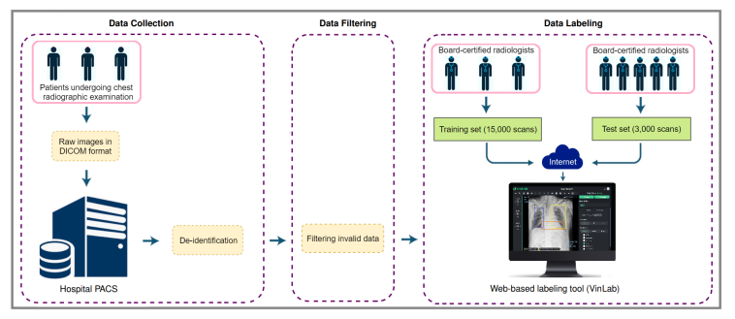

Figure 1: The Building of VinDr-CXR Dataset

## 4.2.1 . Data Collection

## The Data which we require is collected from hospitals in bulk from the patients under going chest examination , To protect patients privacy all personally identifiable information associated with the images are removed or replaced with random values . All the DICOM tags of Protected Health Information (PHI) such as patient’s name , patient’s date of birth , patient Id , or acquisition date and time are removed , Only a limited number of DICOM attributes are retained that are necessary for processing raw images and for clinical reference like patient’s sex and age .

**4.2.2 Data Filtering**

The collected raw data was mostly of adult PA-view CXRs, but also included a significant amount of outliers such as images of body parts other than chest (due to mismatched DICOM tags), pediatric scans, low-quality images, or lateral CXRs. Examples of these images are shown in Figure 2. All outliers were automatically excluded from the dataset using a binary classifier, which is a light-weight convolutional neural network (CNN).

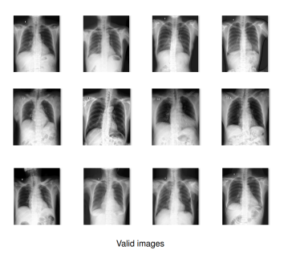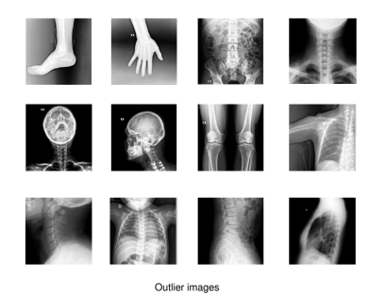

**Figure 2.** Examples of valid (**left**) and invalid (**right**) CXR scans. A CNN-based classifier was trained and used to automatically filter outliers; only valid PA-view CXRs of adults were retained for labeling.

**4.2.3 Data Labeling**

This is a preprocessing step mainly used for separating the images which can be diagnosed easily. This step is essential in separating the data in the data set according to various visible factors which do not require much of technical observation.

The Data returned back after the processing is the images in JSON format in which the ribs are labelled from L1 to L10 and R1 to R10 . The whole training set images will be having their own result . a labelled X-ray image . these can be further used for medical diagnosis , disease determination and for further reference

**4.3 VinDr-CXR Dataset**

VinDr-RibCXR a benchmark dataset for the automatic segmentation and labeling of

individual ribs on CXRs has been used for reference.

The flow of creating VinDr-CXR dataset :

(1) raw images in DICOM format were collected retrospectively from the hospital’s PACS and got de-identified to protect patient’s privacy.

(2) invalid files, such as images of other modalities, other body parts, low quality, or incorrect orientation, were automatically filtered out by a CNN-based classifier.

(3) A web-based labeling tool, VinLab, was developed to store, manage, and remotely annotate DICOM data.

The VinDr-RibCXR Data set consists of 245 AP/PA CXR images for segmentation and labeling of individual ribs, out of which 49 images are of validation set .

## 4.4 Masking and Segmentation

DICOM stands for Digital Imaging and Communications in Medicine. It is **a standard, internationally accepted format to view, store, retrieve and share medical images**.DICOM conforms to set protocols to maintain accuracy of information relayed through medical images. The raw images in the dataset are present in DICOM format. These are processed by using various deep learning algorithms, using various state-of-the art DL based segmentation models . These models take up the task of individual rib segmentation and labeling . The models used are :

* Vanila U-net
* U-net
* U-net with Efficient – B0
* Feature Pyramid Network (FPN)
* U-Net++ with imagenet

The above models are convolution neural networks for image segmentation . A Convolutional Neural Networks (CNN)

## 4.4.1 U-net

U-net is a Fully Convolution neural network for image semantic segmentation.

It consists of encoder and decoder pars connected with skip connections . The Encoder extracts the features of different spatial resolution (skip connections) which are used by decoder to define accurate segmentation mask, Concatenation is used for fusing decoder blocks with skip connections.

**4.4.2 The U-Net Architecture :**

U-net learns segmentation in a end to end setting i.e an input is taken and a output is returned. The First part is called down or encoder part where you apply convolution blocks followed by a max-pool down sampling to encode the input image into feature representations at multiple different levels.

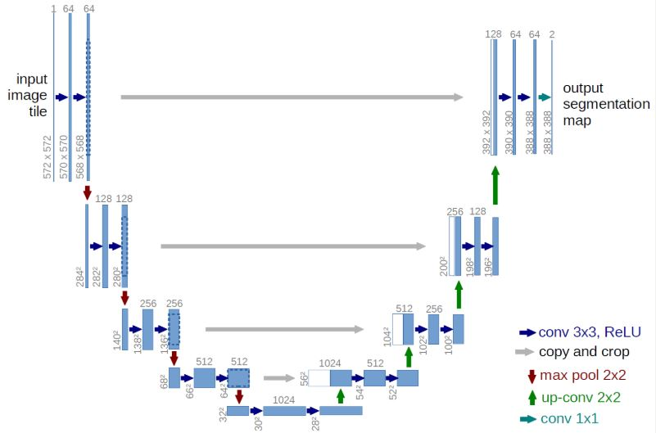

Figure 3: The U-net Architecture

The second part of the network consists of upsample and concatenation followed by regular convolution operations. Upsampling in CNNs may be a new concept to some of the readers but the idea is fairly simple: we are expanding the feature dimensions to meet the same size with the corresponding concatenation blocks from the left. You may see the gray and green arrows, where we concatenate two feature maps together. The main contribution of U-Net in this sense compared to other fully convolutional segmentation networks is that while upsampling and going deeper in the network we are concatenating the higher resolution features from down part with the upsampled features in order to better localize and learn representations with following convolutions. Since upsampling is a sparse operation we need a good prior from earlier stages to better represent the localization. Similar idea of combining matching levels is also seen in FPNs (Feature Pyramidal Networks).

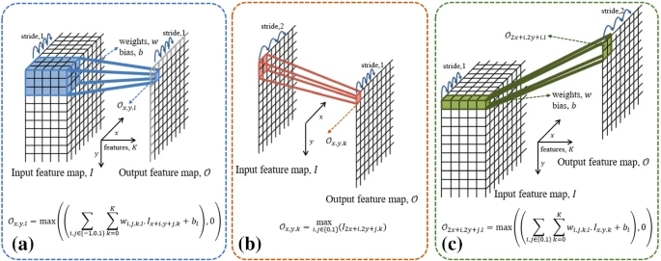

a) Only valid part of convolution is used , for 3x3 convolutions a 1-pixel border is lost .

b) 2x2 max-pooling, resulting feature map has factor 2 lower spatial resolution .

c)2x2 up-convolution , resulting feature maps have factor 2 higher resolution .

**4.4.3 Building a U-net model for segmentation**

Step-1: Importing the required libraries

import albumentations

import torch.nn as nn

import matplotlib.pyplot as plt

import torch

import os

import numpy as np

from pathlib import Path

from PIL import Image

import pandas as pd

from torch.utils.data import ConcatDataset, Dataset, DataLoader,

Subset

import torchvision.transforms as transforms

import torch.optim as optim

import torchvision

import random

import cv2

import time

from albumentations import Compose, HorizontalFlip, Normalize, VerticalFlip, Rotate, Resize, ShiftScaleRotate, OneOf, GridDistortion, OpticalDistortion, ElasticTransform, IAAAdditiveGaussianNoise, GaussNoise, MedianBlur, Blur, CoarseDropout,RandomBrightness Contrast

from albumentations.pytorch import ToTensorV2

Step-2 : selecting the images from data set and creating masks , the images ,labels and masks are placed in separate lists.

class multi_ribs_dataset(Dataset):

def __init__(self,df,transforms,mode,list_label=[]):

self.df=df

self.transforms= transforms

self.mode=mode

self.list_label=list_label

def __len__(self):

return len(self.df['img'])

def __getitem__(self,index):

img_path=self.df['img'][index]

img=Image.open(img_path)

img=img.convert('L')

img=np.asarray(img,dtype=np.float32)

label0=[]

for name in self.list_label:

pts=self.df[name][index]

label= np.zeros((img.shape[:2]),dtype=np.uint8)

if pts!='None':

pts= np.array([[[int(pt['x']),int(pt['y'])]] for pt in pts ])

label=cv2.fillPoly(label,[pts],255)

label0.append(label)

label0=np.stack(label0)

img=img/255

label0=label0/255

label0=label0.transpose((1,2,0))

img=np.expand_dims(img,axis=2)

dic=self.transforms[self.mode]\

( image=img,mask=label0)

img=dic['image']

mask=(dic['mask'].permute(2,0,1))

return img, mask

Step -3 : Segmentation model

import torchvision

import timm

from timm.models.layers.adaptive_avgmax_pool import

SelectAdaptivePool2d

import segmentation_models_pytorch as smp

from monai.networks.nets import Unet,BasicUnet

‘unet(name)’== cfg.MODEL.NAME:

Model = smp.Unet(

encoder_name=’name’,

classes=cfg.MODEL.NUM_CLASSES,

encoder_weight=“ imagenet“,

in_channels=cfg.DATA.INP_CHANNEL

)

return model

The encoders which can be used are resnet50, resnet101, densnet121, densnet169.

For using with other versions of U-net and FPN the model is slightly modified , previous two

steps are same for all the CNN’s . The solver ,tool and utilities are collectively coded keeping

all the convolutional neural networks taken into consideration in mind thus making it feasible

to run the same code for all models

**4.5. Analysing using various CNN**

Along with U-net **,** U-net++ , FPN (Feature Pyramid Network) , etc are used with the encoders resnet50 , resnet101 , densenet121, densenet169 , deeplabV3 , effecientnet-b0 , b3 are used in combination .

The initial requirements i.e libraries are all imported in the start which include the resources required for these convolutional neural networks too. And the images are placed in a list and the masks and labels are also listed. Adaptive pooling is used in all models.

**4.5.1 Building the model**

The data(image) is encoded into feature representations based on these parametered values ,these are for initial segregation and to find which CNN gives the better results i.e fast and accurate results.

def build_model(cfg):

if 'unet(resnet50)'== cfg.MODEL.NAME:

model=smp.Unet('resnet50',classes=cfg.MODEL.NUM_CLASSES,encoder_weights=

'imagenet',in_channels=cfg.DATA.INP_CHANNEL)

# resnet101,densenet121, densenet169 can be used like renet50

elif 'deeplabv3(resnet50)' == cfg.MODEL.NAME:

model=smp.DeepLabV3('resnet50',classes=cfg.MODEL.NUM_CLASSES,in_channels=

cfg.DATA.INP_CHANNEL)

elif 'unet(b3)'== cfg.MODEL.NAME:

model=smp.Unet('efficientnetb3',classes=cfg.MODEL.NUM_CLASSES,

encoder_weights='imagenet'\ ,in_channels=cfg.DATA.INP_CHANNEL)

#Using U-net++

elif 'unet++()'== cfg.MODEL.NAME:

model=NestedUNet(cfg)

elif 'unet++(resnet101)'== cfg.MODEL.NAME:

model=smp.UnetPlusPlus('resnet101',classes=cfg.MODEL.NUM_CLASSES,

encoder_weights='imagenet'\ ,in_channels=cfg.DATA.INP_CHANNEL)

#In this Unet++ can have various encoders such as b0, b3, resnet50 etc.

#Using FPN

elif('fpn(b0)'==cfg.MODEL.NAME): model=smp.FPN('efficientnetb0',classes=cfg.MODEL.NUM_CLASSES

,encoder_weights='imagenet',\in_channels=cfg.DATA.INP_CHANNEL,

decoder_dropout=cfg.MODEL.DROPOUT )

#Using Unet efficient b0 and B3

elif 'unet(b0)'== cfg.MODEL.NAME:

model=smp.Unet('efficientnetb0',classes=cfg.MODEL.NUM_CLASSES,

encoder_weights='imagenet'\ ,in_channels=cfg.DATA.INP_CHANNEL)

elif 'unet++(b3)'== cfg.MODEL.NAME:

model=smp.UnetPlusPlus('efficientnetb3',classes=cfg.MODEL.NUM_CLASSES,

encoder_weights='imagenet'\ ,in_channels=cfg.DATA.INP_CHANNEL)

return model

**4.5.2 Creating optimizer with per-layer learning rate and weight decay**

Algo: params = [ ]

for key in model.named_parameters():

if not value.requires_grad:

continue

lr = cfg.SOLVE.BASE_LR

weight_decay = cfg.SOLVER.WEIGHT_DECAY

if "bias" in key:

weight_decay = cfg.SOLVER.WEIGHT_DECAY_BIAS

params += [{"params": [value], "lr": lr, "weight_decay": weight_decay,'initial_lr':lr}]

if cfg.SOLVER.OPTIMIZER == "adamw":

optimizer = torch.optim.AdamW(params, lr, eps=cfg.SOLVER.ADAM_EPS)

elif cfg.SOLVER.OPTIMIZER == "sgd":

optimizer = torch.optim.SGD(params, lr, momentum=0.9, nesterov=True)

return optimizer

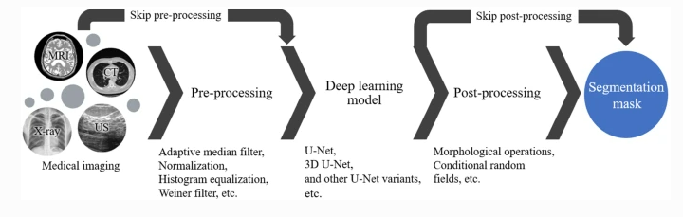

Figure 5 : Workflow - The figure demonstrates how the images are processed

# Chapter 5 Experimental Procedure

We implement Ribs Identification code in Pythorch (v1.7.1) , A NVIDIA RTX 280 Ti GPU is recommended , as it needs to run CUDA if CUDA is disabled and then it is optional . Check whether all the repositories are present and are of up-to-date.

**Selection of Data Set:**

Most of existing CXR datasets depend on automated rule-based labelers that either use keyword matching (e.g. CheXpert and NIH labelers) or an NLP model (e.g. CheXbert) to extract disease labels from free-text radiology reports. These tools can produce labels on a large scale but, at the same time, introduce a high rate of inconsistency, uncertainty, and errors. These noisy labels may lead to the deviation of deep learning-based algorithms from reported performances when evaluated in a real-world setting. Furthermore, the report-based approaches only associate a CXR image with one or several labels in a predefined list of findings and diagnoses without identifying their locations. There are a few CXR datasets that include annotated locations of abnormalities but they are either too small for training deep learning models (JSRT) or not detailed enough (PadChest). The interpretation of a CXR is not all about image-level classification; it is even more important, from the perspective of a radiologist, to localize the abnormalities on the image. This partly explains why the applications of CAD systems for CXR in clinical practice are still very limited.

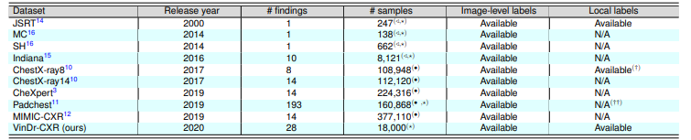

Table 1 : (_) Labeled by an NLP algorithm. (?) Labeled by radiologists. (/) Moderate-size datasets that are not applicable for training deep learning models. (†) A portion of the dataset (983 images) is provided with hand-labeled bounding boxes. (††) 27% of the dataset was manually annotated with encoded anatomical regions of the findings.

Dataset namely VinDr-RibCXR, of 245 AP/PA CXR images for segmentation and labeling of individual ribs .To develop and evaluate segmentation algorithms, the whole dataset into a training set of 196 images and a validation set of 49 images is used to compare the performance using various CNN’s.

**Use this command to run : python main.py --config/cvcore/multi_unet_b0_diceloss.yaml**

The above command is used and the results are recorded and the same experiment is proceded using other datasets like Shenzen data and JSRT data and the results are recorded.

# Chapter 6 Results and Discussion

We have conducted various tests with our model using various large datasets and Convolution neural networks with various encoders .These tests were classified into two categories.

1. Experiment using a data set and multiple CNN’s
2. Experiment using various datasets

## Experiment using A Single Dataset and multiple CNN’s

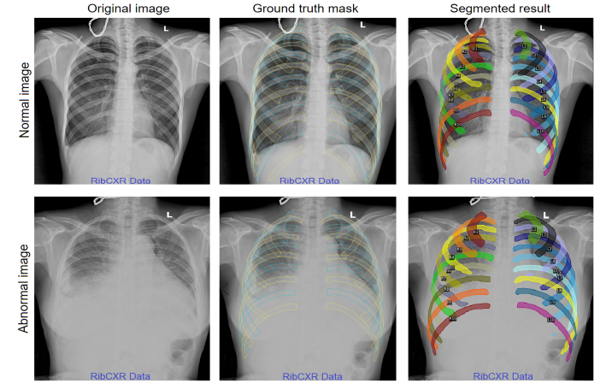We have conducted tests using different combinations , The CNN’s are compatable with its own set of encoders having its own parameter set and characteristics such as encoder_weight , encoder_depth , in_channels , decoder_attention_type ,classes , an activation function to apply after the final convolution layer , pooling , dropout factor in [0,1) etc.

Figure 6 : The figure depicts the process of identification and labeling of ribs

The effectiveness of the segmentation models was evaluated by Dice score, 95% Hausdor distance (95% HD), sensitivity, and specifcity. Experimental results reported by the proposed segmentation models are shown in Table 2. Our best performing model, which was Nested U-Net with EfficientNet-B0 encoder, achieved a Dice score of 0.834 (95% CI, 0.810{0.853), a 95% HD of 15.453 (95% CI, 13.340{17.450), a sensitivity of 0.841 (95% CI, 0.812{0.858), and a specificity 0.998 (95% CI, 0.997{0.998) .

Table 2: Segmentation performance on the validation set of VinDr-RibCXR

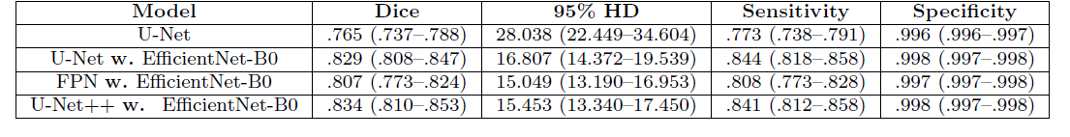

The Below figure shows the result of a CXR taken from the VinDr-RibCXR dataset, depicting the all the 20 bones labelled as L1 to L10 ( left ribs) R1 to R10 (right ribs) the 2 upper bones which are connected one to head and one to thoracic vertebrae.

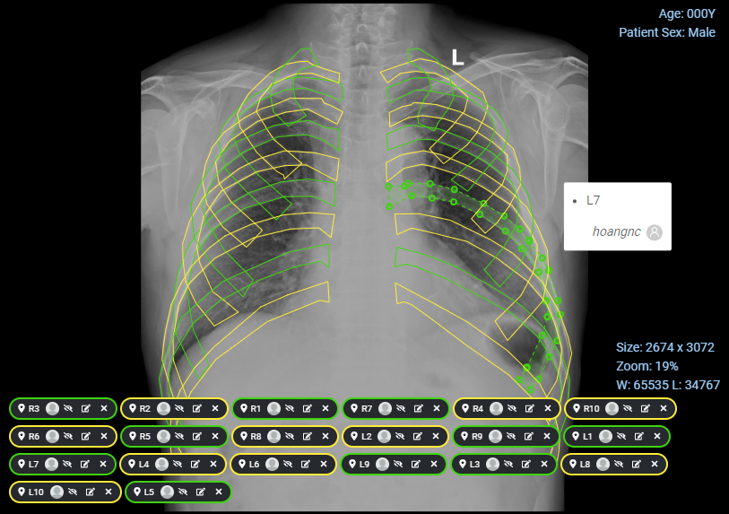

Figure 7 : The detailed labeled result of the chest X-ray Showing the Ribs along with numbering on the anterior and posterior bones.

**6.3. Experiments using various Datasets**

The Figure 8 shows segmentation and labeling results of the Nested U-Net on some representative cases from the validation set of VinDr-RibCXR and external datasets including JSRT and Shenzen. We observe that the algorithm correctly segmented the individual ribs on both normal and abnormal CXR scans, for both the VinDr-RibCXR and two external datasets. Although the abnormal CXR contains ribs that are obscured by lung abnormalities, the proposed algorithm still produced a considerably accurate segmentation mask for all ribs.



Figure 8: Segmentation results on our validation set and two external datasets.

# Chapter 7 Conclusion and Future Scope

Unlike Traditional handpicking and examination of Chest X-Rays is done by using the Segmentation models which not only help to identify the anterior ribs along with the posterior ribs they also make it faster and easier to deal with large amounts of data and helps in easy medical diagnosis reducing the time taken for manual examination of the X-rays thus decreasing the burden on doctors and also conserves the doctors valuable time which can be spent in treating other patients. Our model not only identifies ribs but also labels them making it easier to diagnosis which bone is injured or broken, and also it even works well with X-rays of people having lungs abnormalities.

Future work may include investigating more powerful DL models and extending the dataset to enhance the segmentation performance. Further we can extend the scope of the project by adding the ability of detecting/diagnosing the diseases of the patients and helps the doctors in quick analysis and enhances the ability, quality and reliability in medical diagnosis.

# Chapter 8 References

1. https://www.topdoctors.co.uk/medical-dictionary/abnormal-chest-x-ray
2. Deep Learning for chest X-ray analysis : A survey , Radboud University Medical Center, Institute for Health Sciences, Department of Medical Imaging, Nijmegen, the Netherlands https://www.sciencedirect.com/science/article/pii/S1361841521001717 , 2021 .
3. https://ai.googleblog.com/2021/09/detecting-abnormal-chest-x-rays-using.html
4. [rbgirshick/yacs: YACS -- Yet Another Configuration System (github.com)](https://github.com/rbgirshick/yacs?msclkid=aea5e7b2bad211eca87979f94538fd4d)
5. [📦 Segmentation Models — Segmentation Models documentation (smp.readthedocs.io)](https://smp.readthedocs.io/en/latest/models.html#unet).

[qubvel/segmentation_models.pytorch: Segmentation models with pretrained backbones. PyTorch. (github.com)](https://github.com/qubvel/segmentation_models.pytorch#architectures) .

1. <https://analyticsindiamag.com/my-experiment-with-unet-building-an-image-segmentation-model/> - Understanding Basics of Building A U-Net model.
2. [VinDr-RibCXR: A Benchmark Dataset for Automatic Segmentation and Labeling of Individual Ribs on Chest X-rays | VinDr](https://vindr.ai/datasets/ribcxr) – Licensed Agreement for usage of Dataset VinDr-RibCXR .

# ACKNOWLEDGEMENT

The satisfaction and euphoria that accompany the successful completion of any task would be incomplete without the mention of people who made it possible, whose constant guidance and encouragement crowned our efforts with success. It is a pleasant aspect that I have now the opportunity to express my gratitude for all of them.

We owe our sincere gratitude to our project guide Dr. Sri Latha C, Department of Computer Science, National Institute of Technology, Andhra Pradesh, who took keen interest and guided us all along, till the completion of our project work by providing all the necessary information.

We avail ourselves of this proud privilege to express our gratitude to all the faculty of the department of Computer Science and Engineering at NIT Andhra Pradesh for emphasizing and providing us with all the necessary facilities throughout the work.

We offer our sincere thanks to all our friends, fellow mates and other persons who knowingly or unknowingly helped us to complete this project.

|  |  |
| --- | --- |
| Mediboyina Rupesh Kumar Yadav |  |
| 420207 |  |
| Date : 29-04-2022 |  |